Matt Descoteaux

ENTD200 D003 Winter 2021

Ms. Cichocki

Week 5

03 Apr 2021

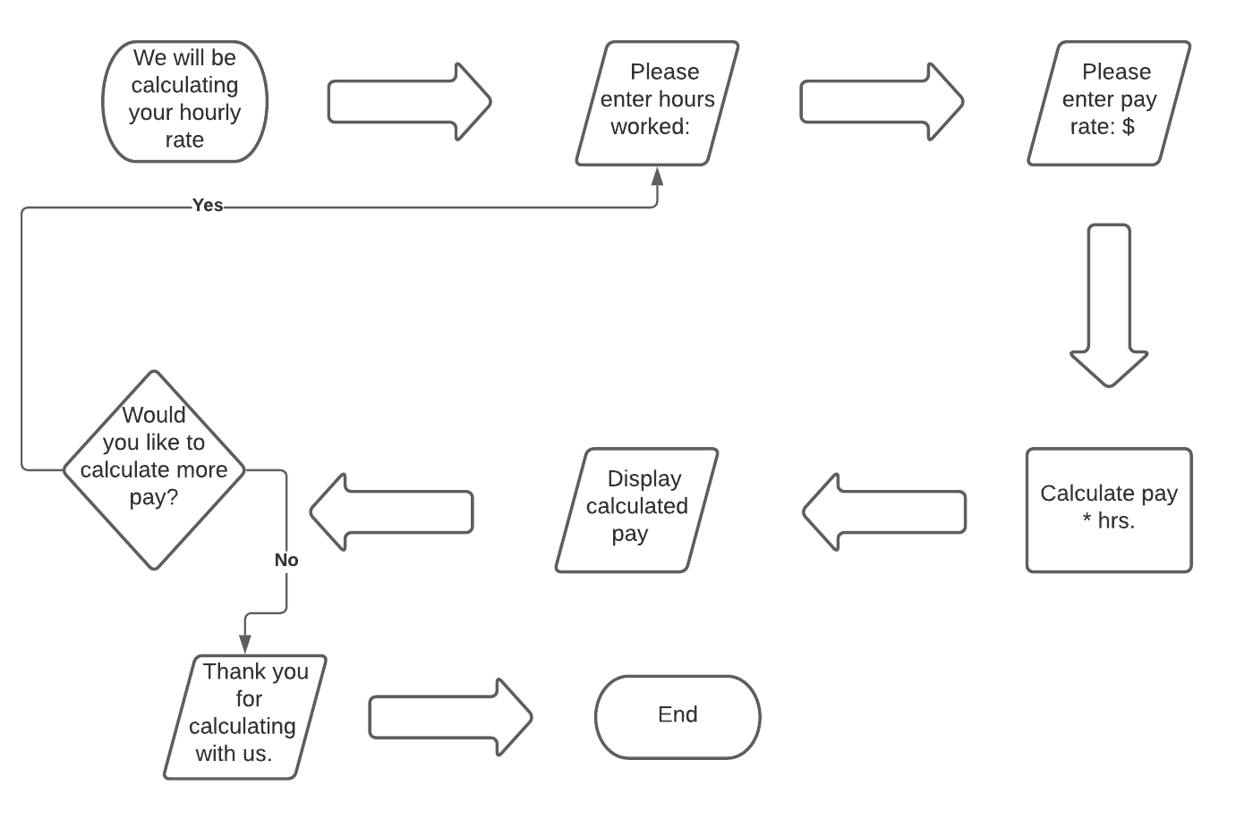

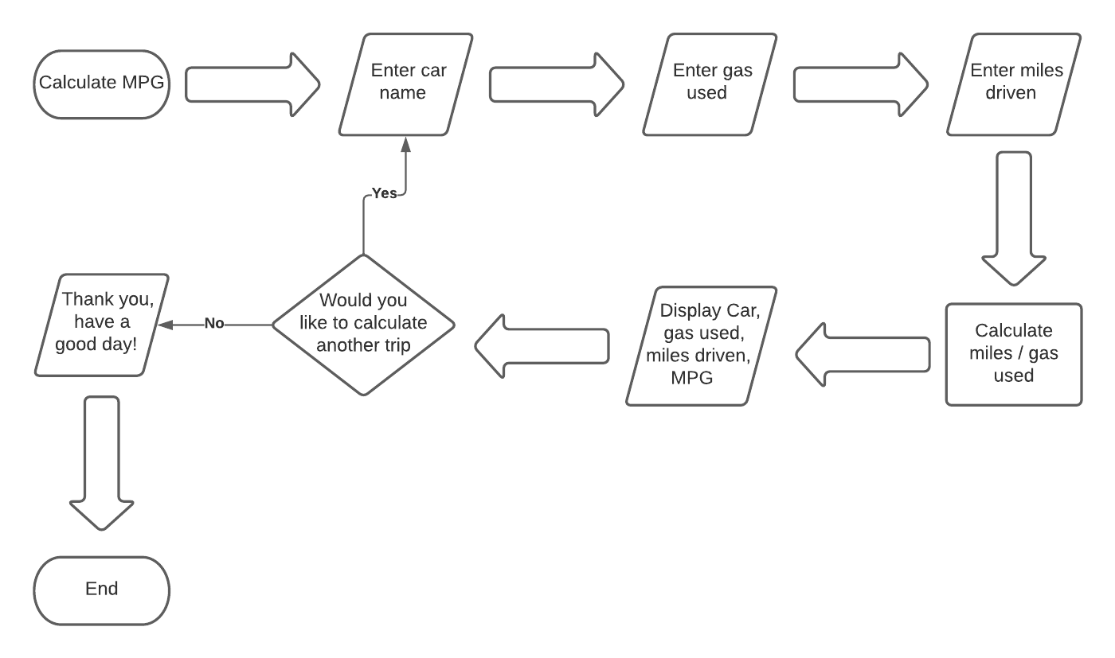

PSEUDO CODE

Print Let’s calculate your hourly rate

Please input hours worked

Input hours worked

Please input pay rate

Input pay rate

Calculate gross pay

Hours \* pay

Print gross pay

Print would you like to calculate more pay

If == yes

Input hours worked

Else:

print(thank you have a nice day)

Print Let’s calculate MPG on trip

Please input vehicle model

Input vehicle model

Please input miles driven

Input miles driven

Please input gas used

Input gas used

Calculate MPG

Miles / gas used

Print vehicle model, miles driven, gas used, MPG

Print would you like to calculate another trip

If == yes

input car model

Else:

print(Thank you have a nice day)